# PCM1789- Q1

Control Interface

The following inputs are used to control the functionalities of the DAC:

* The MODE input determines the operational mode of the PCM1789. There are two modes: Standard Mode and Double Speed Mode. In Standard Mode, the PCM1789 operates with a sampling frequency of up to 50 kHz, while in Double Speed Mode, the sampling frequency can go up to 100 kHz.
* To set the mode to DOUBLE SPEED, the MODE input should be set to '0' for the double-speed mode. If MODE is set to '1', it will be in normal speed mode.

Inputs: MODE pin (logic high or low)

Outputs: None

Modes: Standard, Double Speed, Quad Speed, and Dual Mono

Control port mode selection. Tied to VDD: SPI, ADR6 = 1, pull-up: SPI,  
ADR6 = 0, pull-down: H/W auto mode, tied to DGND: I2C

Mode input pin is for selection of the control mode. Dependant on the ADR6, the pin should have a pull- Up/down resistor. Logic high so VDD is SPI and Logic low so DGND is I2C.

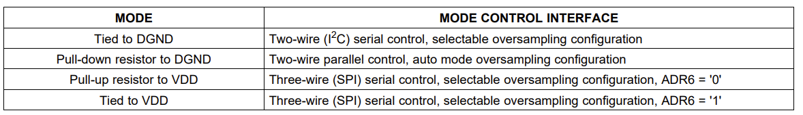

* The ADR5/ADR1/RSV inputs are used to set the device address when multiple PCM1789s are used in a system.
* These address inputs are used to select the register to be accessed during the write operation. The RSV bit should always be set to 0.

Inputs: ADR5-ADR1 pins (binary address), RSV pin (logic high or low)

Outputs: None

* The MS/ADR0/RSV inputs are used for I2C communication. MS selects the I2C bus master, while ADR0/RSV is used to set the device address.
* The MS input selects the operation mode of the device. For TDM mode, this input should be set to 1. ADR0 is another address input used to select the register to be accessed, and RSV should be set to 0.

Mode Control:

Inputs: MS pin (logic high or low), ADR0 pin (control address), RSV pin (logic high or low)

Outputs: None

Modes: De-emphasis, Soft Mute, Zero Detect, Digital Attenuation, and Digital Filter

* The MC/SCL/FMT input determines the type of interface used for communication with the PCM1789. MC selects between SPI or I2C interfaces, while SCL selects between I2S, MSB-First, and LSB-First data formats.
* The MC input sets the serial data format. For TDM mode, this input should be set to 1. SCL is the I2C clock input and FMT selects the audio data format.

Master/Slave Selection:

Inputs: MC pin (logic high or low), SCL pin (serial clock), FMT pin (audio data format)

Outputs: None

Modes: Master and Slave

* The MD/SDA/DEMP input is used for I2C communication. MD selects between read and write operations, while SDA is the I2C data line. DEMP is used to disable the output of the PCM1789 during mute and soft-mute operations.
* MD input is the I2C data input and SDA is the I2C data output. For TDM mode, DEMP should be set to 0 to disable deemphasis.

Data Control:

Inputs: MD pin (serial data), SDA pin (serial data address), DEMP pin (de-emphasis enable)

Outputs: None

* The RST input is used to reset the PCM1789 to its power-up state.

Reset Control:

Inputs: RST pin (logic high or low)

Outputs: None

* The AMUTEI input is used to mute the audio output of the PCM1789.
* This input enables or disables the automatic mute function on the input channels.

* The ZERO1 and ZERO2/AMUTEO inputs are used for zero-crossing detection and for controlling the output stage of the PCM1789.
* These inputs and output are used to control the output signal level and enable or disable the automatic mute function on the output channels.

Inputs: AMUTEI pin (audio mute input), ZERO1 pin (zero detect input), ZERO2/AMUTEO pin (audio mute output)

Outputs: None